1: Sarah goes to the shops on a hot summer day, wearing shorts and a singlet. While she is in the freezer section, her body starts to cool and Sarah begins to shiver.

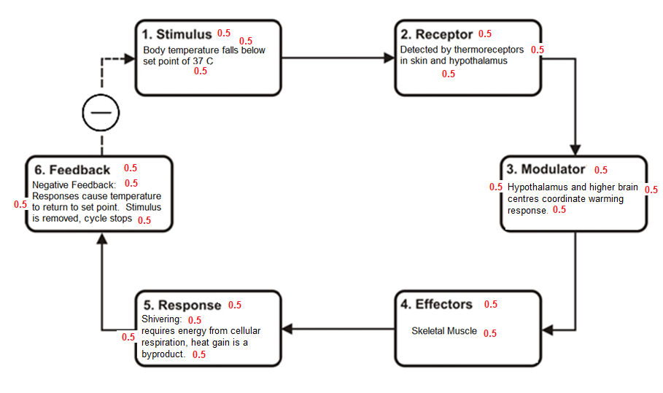Use a steady-state control model to explain why Sarah begins to shiver. (10 marks)

…………………………………………………………………………………………………………………………………………………………………………

…………………………………………………………………………………………………………………………………………………………………………

…………………………………………………………………………………………………………………………………………………………………………

…………………………………………………………………………………………………………………………………………………………………………

…………………………………………………………………………………………………………………………………………………………………………

…………………………………………………………………………………………………………………………………………………………………………

…………………………………………………………………………………………………………………………………………………………………………

…………………………………………………………………………………………………………………………………………………………………………

…………………………………………………………………………………………………………………………………………………………………………

…………………………………………………………………………………………………………………………………………………………………………

…………………………………………………………………………………………………………………………………………………………………………

…………………………………………………………………………………………………………………………………………………………………………

…………………………………………………………………………………………………………………………………………………………………………

…………………………………………………………………………………………………………………………………………………………………………

…………………………………………………………………………………………………………………………………………………………………………

…………………………………………………………………………………………………………………………………………………………………………

…………………………………………………………………………………………………………………………………………………………………………

1: Sarah goes to the shops on a hot summer day, wearing shorts and a singlet. While she is in the freezer section, her body starts to cool and Sarah begins to shiver.

Use a steady-state control model to explain why Sarah begins to shiver. (10 marks)

…………………………………………………………………………………………………………………………………………………………………………

…………………………………………………………………………………………………………………………………………………………………………

…………………………………………………………………………………………………………………………………………………………………………

…………………………………………………………………………………………………………………………………………………………………………

…………………………………………………………………………………………………………………………………………………………………………

…………………………………………………………………………………………………………………………………………………………………………

…………………………………………………………………………………………………………………………………………………………………………

…………………………………………………………………………………………………………………………………………………………………………

…………………………………………………………………………………………………………………………………………………………………………

…………………………………………………………………………………………………………………………………………………………………………

…………………………………………………………………………………………………………………………………………………………………………

…………………………………………………………………………………………………………………………………………………………………………

…………………………………………………………………………………………………………………………………………………………………………

…………………………………………………………………………………………………………………………………………………………………………

…………………………………………………………………………………………………………………………………………………………………………

…………………………………………………………………………………………………………………………………………………………………………

…………………………………………………………………………………………………………………………………………………………………………